**9**

**Science -STE**

**Learning Activity Sheets** Quarter 2: Week 1-2

**Food Preservatives, Artificial Sweetening Agents and Food**

**Additives**

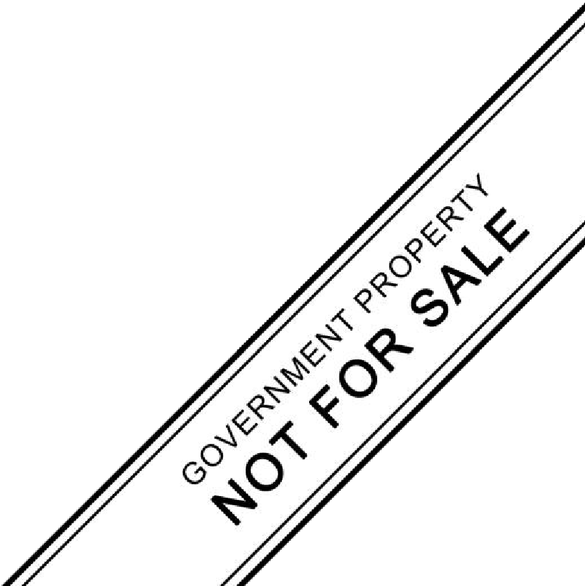

**CONSUMER CHEMISTRY – STE 9**

Name: Hugo P. Molina **Q2W1-2**

Grade Level & Section: 9-Cytosine Date: Jan. 4, 2020

**Food Preservatives, Artificial Sweetening Agents and Food Additives**

# Background Information

Foods are materials, raw, processed, or formulated, that are consumed orally by humans or animals for growth, health, satisfaction, pleasure, and satisfying social needs. Generally, there is no limitation on the amount of food that may be consumed (as there is for a drug in the form of dosage). This does not mean that we can eat any food item as much as we want. Excessive amounts could be lethal, for example, salt, fat, and sugar. Chemically, foods are mainly composed of water, lipids, fat, and carbohydrate with small proportions of minerals and organic compounds. Minerals include salts and organic substances include vitamins, emulsifiers, acids, antioxidants, pigments, polyphenols, and flavor-producing compounds. The different classes of foods are perishable, nonperishable, harvested, fresh, minimally processed, preserved, manufactured, formulated, primary, secondary derivatives, synthetic, functional, and medical foods.

**Food Preservatives** constitute a group of compounds of widely different molecular structures; they are organic and inorganic substances with different functional groups and tendencies to form ions. Food preservation also refers as any of a number of methods by which food is kept from spoilage after harvest or slaughter. Such practices date to prehistoric times. Among the oldest methods of preservation are drying, refrigeration, and fermentation. Modern methods include canning, pasteurization, freezing, irradiation, and the addition of chemicals. Advances in packaging materials have played an important role in modern food preservation.

**Food Additive** is any substance added to food. Legally, the term refers to "any substance the intended use of which results or may reasonably be expected to result -- directly or indirectly -- in its becoming a component or otherwise affecting the characteristics of any food." This definition includes any substance used in the production, processing, treatment, packaging, transportation or storage of food.

**Direct food additives** are those that are added to a food for a specific purpose in that food. For example, xanthan gum -- used in salad dressings, chocolate milk, bakery fillings, puddings and other foods to add texture -- is a direct additive. Most direct additives are identified on the ingredient label of foods.

**Indirect food additives** are those that become part of the food in trace amounts due to its packaging, storage or other handling. For instance, minute amounts of packaging substances may find their way into foods during storage. Food packaging manufacturers must prove to the U.S. Food and Drug Administration (FDA) that all materials coming in contact with food are safe before they are permitted for use in such a manner.

**Why Are Food and Color Ingredients Added to Food?**

To Maintain or Improve Safety and Freshness: Preservatives slow product spoilage caused by mold, air, bacteria, fungi or yeast. In addition to maintaining the quality of the food, they help control contamination that can cause foodborne illness, including life-threatening botulism. One group of preservatives -- antioxidants -- prevents fats and oils and the foods containing them from becoming rancid or developing an off-flavor. They also prevent cut fresh fruits such as apples from turning brown when exposed to air.

To Improve or Maintain Nutritional Value: Vitamins and minerals (and fiber) are added to many foods to make up for those lacking in a person's diet or lost in processing, or to enhance the nutritional quality of a food. Such fortification and enrichment have helped reduce malnutrition in the U.S. and worldwide. All products containing added nutrients must be appropriately labeled.

To Improve Taste, Texture and Appearance: Spices, natural and artificial flavors, and sweeteners are added to enhance the taste of food. Food colors maintain or improve appearance. E. Leavening agents allow baked goods to rise during baking.

**How are ingredients listed on a product label?**

Food manufacturers are required to list all ingredients in the food on the label. On a product label, the ingredients are listed in order of predominance, with the ingredients used in the greatest amount first, followed in descending order by those in smaller amounts. The label must list the names of any FDA-certified color additives (e.g., FD&C Blue No. 1 or the abbreviated name, Blue 1).

The E **system,** developed by the European Union (formally the European Economic Community), provides a listing of several commonly used additives. The Codex Alimentarius Commission Committee on Food Additives and Contaminants has developed an international numbering system (INS) for food additives based on the E system. The INS systems broader than the E system and is intended as an identification system for food additives approved for use in one or more countries. The INS numbers are largely the same numbers used in the E system without the E. The INS system also includes a listing of the technical function for each additive based on 23 functional classes. The E numbers are categorized as follows:

|  |  |  |  |
| --- | --- | --- | --- |
| • • •  • | E100–E199 (colors)  E200–E299 (preservatives)  E300–E399 (antioxidants, acidity regulators)  E400–E499 (thickeners, stabilizers, emulsifiers) | •  • •  • | E500–E599 (acidity regulators, anticaking agents)  E600–E699 (flavor enhancers) E900–E999 (surface coating agents, gases, sweeteners)  E1000–E1999 (additional chemicals) |
| Table 1: lists the types of common food ingredients | | |

**Types of Names Found on**

**What They Do Examples of Uses**

# Ingredients Product Labels

sodium nitrite, BHT,

Prevent food spoilage margarines, cereals, ,

**Preservatives** EDTA, tocopherols

from antimicrobials; fruits and vegetables

(Vitamin E) saccharin, aspartame,

Add sweetness with or

Beverages, baked sucralose, acesulfame

**Sweeteners** without the extra goods, confections, potassium (acesulfamecalories

K),

Offset color loss due to FD&C Blue Nos. 1 exposure to light, air, extract, beta-carotene,

**Color Additives** temperature extremes, Many processed foods, grape skin extract,

moisture and storage cochineal extract or

conditions carmine,

**Flavors and** Add specific flavors gelatin dessert mixes, Natural flavoring, artificial

**Spices** (natural and synthetic) cake mixes, salad flavor, and spices Monosodium glutamate

**Flavor** Enhance flavors Many processed foods

(MSG), hydrolyzed soy

**Enhancers** already present in foods chewing gum

protein,

Olestra, cellulose gel, Baked goods,

Provide expected carrageenan,

dressings, frozen texture and a creamy polydextrose, modified

**Fat Replacers** desserts, confections,

"mouth-feel" in reduced- food starch,

cake and dessert fat foods microparticulate egg

mixes, dairy products

white protein, guar gum,

Replace vitamins and Flour, breads, cereals, Thiamine hydrochloride,

**Nutrients** minerals lost in rice, macaroni, riboflavin (Vitamin B2),

processing margarine, niacin, niacinamide,

Allow smooth mixing of peanut butter,

Soy lecithin, mono- and

**Emulsifiers** ingredients, prevent chocolate, margarine,

diglycerides, separation frozen desserts

Frozen desserts, dairy

# Stabilizers and

Produce uniform products, cakes, Gelatin, pectin, guar gum,

**Thickeners,** texture, improve pudding and gelatin carrageenan, xanthan

# Binders,

"mouth-feel" mixes, dressings, jams gum, whey

**Texturizers** and jellies, sauces Beverages, frozen **pH Control** Control acidity and Lactic acid, citric acid,

desserts, chocolate,

**Agents and** alkalinity, prevent ammonium hydroxide,

low acid canned foods, **acidulants** spoilage sodium carbonate

baking powder

Baking soda,

**Leavening** Promote rising of baked Breads and other

monocalcium phosphate,

**Agents** goods baked goods

calcium carbonate

Keep powdered foods Calcium silicate, iron

**Anti-caking** Salt, baking powder, free-flowing, prevent ammonium citrate, silicon

**agents** confectioner's sugar

moisture absorption dioxide

Maintain crispness and Processed fruits and Calcium chloride, calcium

# Firming Agents

firmness vegetables lactate

Serve as propellant, Oil cooking spray,

Carbon dioxide, nitrous

**Gases** aerate, or create whipped cream,

oxide carbonation carbonated beverages

**SWEETENER or SUGAR** is any of various natural and artificial substances that provide a sweet taste in food and beverages. In addition to their sweetening power, they may be used for such processes as food preservation, fermentation (in brewing and wine making), baking (where they contribute to texture, tenderization, and leavening), and food browning and caramelization.

Natural sugars are mainly extracted from animal or plant sources, and they are derived as a result of a natural process such as photosynthesis in a plant. These sugar substitutes are low in calories, low in fructose and taste very sweet. Thus, natural sweeteners are considered as a good sugar substitute because they have lesser-to-no calories compared to that of refined sugars often used in cooking and other beverages.

However, these natural sweeteners acquire their sweet taste from glucose and fructose.

They are also associated with positive health outcomes compared to artificial sweeteners.

**Natural sweeteners** are used for following applications;

* To bake (main use)
* To spread on bread or biscuits
* To sweeten various beverages such as tea
* To preserve meat

Sugar substitutes or Artificial Sweeteners are artificially synthesized compounds that give a sweet taste similar to sugar. But they contain considerably less food energy. Excess consumption of artificial sweeteners is associated with detrimental health effects. Artificial sweeteners have been associated with obesity, diabetes, cardiovascular disease, dementia, macular degeneration, and tooth decay. Thus, different food regulation bodies’ including EU Food Additive and the U.S. Food and Drug Administration regulate artificial sweeteners as food additives.

* To sprinkle on foods
* To sweeten hot drinks such as tea and coffee
* To backed products such as baked goods, confectionery, and toffees (Diet products or sugar-free alternative products)
* To add sweetness and texture to cooked products
* To produce icing sugar that is used for dusting foods and in baking and confectionery

# Learning Competency

Describe the chemical properties of food preservatives, artificial sweetening agents and food additives

# Activity 1: Facts On Food Additives

Objectives

1. Identify the food additives found on the different products
2. Make a list on the food additives present on the different products

Direction: Using the Table1. Read and answer the following questions. Write the answer on the lines provided.

Fact no. 1. What is/are the food additives found on bread?

Baked goods – bread, cookies and pastry have Preservatives, sweeteners, Fat Replacers, Nutrients, Stabilizers and Thickeners, Binders, Texturizers, Leavening Agents.

What is/are the food additives found on cookies?

Baked goods – bread, cookies and pastry have Preservatives, sweeteners, Fat Replacers, Nutrients, Stabilizers and Thickeners, Binders, Texturizers, Leavening Agents.

Fact no. 2. What is/are the types of ingredients found on frozen dessert – ice cream?

Frozen desert – ice cream has Emulsifiers and Fat Replacers.

Fact no. 3. What is/are the food additives found on chewing gum?

Chewing gum – color additives and flavor enhancer.

Fact no. 4. What is/are the food additives found on soft drinks?

Soft drinks – sweeteners and color additive.

Guide Questions

1. What are food additives?

Food additives is a substance or mixture of substances, other than a basic foodstuff, which is present in a food as a result of any aspect of production, processing, storage, or packaging.

1. Why does food manufacturer use food additives?

To Maintain or Improve Safety and Freshness, to Improve or Maintain Nutritional Value and to Improve Taste, Texture and Appearance.

1. What is the difference between direct food additives and indirect food additives?

Direct food additives are those that are added to a food for a specific purpose in that food while indirect food additives are those that become part of the food in trace amounts due to its packaging, storage or other handling.

**Activity 2: What can food additives do?**

Objective:Describe the use of each type food additives

Direction: Match column A to column B. Write the letter of the answer on the lines provided.

|  |  |  |  |
| --- | --- | --- | --- |
| Firming Agents  ______ 1.  Flavors and Spices  ______ 2.  Preservatives  ______ 3.  Control Agents and acidulants  ______ 4.  Fat Replacers  ______ 5.  Anti-caking agents  ______ 6.  Nutrients  ______ 7.  Emulsifiers  ______ 8.  Sweeteners  ______ 9.  Emulsifiers | **COLUMN A**  Maintain crispness and firmness  Add specific flavors like banana or strawberry Prevent food spoilage from bacteria, molds, fungi, or yeast  Control acidity and alkalinity prevent moisture absorption  correct natural variations in color; enhance colors that occur naturally  Replace vitamins and minerals lost in processing prevent separation of flour and water  Add sweetness with or without the extra calories | -  -  -  -  -  -  -  -  -  - | **COLUMN B**  Color Additives  Flavors and Spices  Nutrients  Sweeteners Emulsifiers pH Control Agents and acidulants  Anti-caking agents  Emulsifiers  Firming Agents  Preservatives |
| ______ 10. reduce stickiness and control crystallization | |

Guide Questions

1. Does each type of food additives have the same use?

No

1. Why do potatoes snacks like “piatos” remain crunchy?

Because they have firming agents.

1. What food additive is added to make ube flavored milk tea?

Flavor enhancer - ube

**Activity 3: What can food additives be?**

Objective: Recognized whichtype food additives are described on the statement below.

Direction: Complete the table below by categorizing the described ingredients.

|  |  |  |
| --- | --- | --- |
| **Ingredients** | **Type** |  |
| Yellow 5 is also known as tartrazine or E102. Yellow 5 is widely | 1. Color additives |  |
| used in the making of potato chips, jams, candy, drinks and |  |
|  |  |
|  |  |  |



|  |  |  |  |
| --- | --- | --- | --- |
| n pet food. It is also added to shampoo and other cosmetic |  |  |  |
| products, as well as vitamins and certain medications. |  |  |  |
| Monosodium glutamate, also known as sodium glutamate, is the | 2. | Flavor Enhancers |  |
| sodium salt of glutamic acid. MSG is found naturally in some |  |
| foods including tomatoes and cheese. |  |  |  |
|  |  | |  |
| **Ingredients** | **Type** | |  |
| Saffron is a spice derived from the flower of Crocus sativus, |  |  |  |
| commonly known as the "saffron crocus". The vivid crimson | 3. | Color Additives |  |
| stigma and styles, called threads, are collected and dried for |  |
|  |  |  |
| use mainly as a seasoning and colouring agent in food. |  |  |  |
| Hydrolyzed vegetable protein (HVP) products are foodstuffs |  |  |  |
|  |  |  |
| obtained by protein hydrolysis and are used as ingredients to | 4. | Flavor Enhancers |  |
| create a bouillon (broth) taste without the vegetables, bones, |  |
| simmering, or other standard elements of creating bouillon from |  |  |  |
| scratch. |  |  |  |
| Polydextrose is a synthetic polymer of glucose. is frequently | 5. | Fat Replacers |  |
| used to increase the dietary fiber content of food, to replace |  |
| sugar, and to reduce calories and fat content. |  |  |  |
| Nitrite is an easy way to give a pink shade to processed meats. | 6. | Preservatives |  |
| In the meat-packing industry, nitrite is used to prevent botulism. |  |
|  |  |  |
| Lecithin, also known as soy lecithin, is a natural emulsifier and | 7. | Emulsifiers |  |
| stabilizer. |  |
|  |  |  |
| Xanthan gum is a polysaccharide with many industrial uses, | 8. |  |  |
| including as a common food additive. It can be produced from | Fat Replacers |  |
| 9. |  |  |
| simple sugars using a fermentation process. | Stabilizers and Thickeners, Binders, Texturizers |  |
|  |  |  |
| Carbon dioxide is a food additive used as a propellant and | 10. Gases | |  |
| acidity regulator in the food industry. |  |
|  |  |  |



Guide Questions

1. Can nitrate gives color to cured meat?

No, pinkish color of nitrate will be overpowered by natural color of meat.

1. Can you add monosodium glutamate in your egg every breakfast? How?

Yes, by adding cheese and tomatoes.

## Activity 4: Food Codes

Objective: Identify the food additives found on the different products

Direction: Use the International Numbering System in categorizing the following codes.

Complete the table below

|  |  |  |
| --- | --- | --- |
| **Code** | | **Type of Food Additives** |
| 1. E106 | | 1) (colors) |
| 2. E239 | | 2) (preservatives) |
| 3. E909 | | 3) (surface coating agents, gases, sweeteners) |
| 4. E1222 | | 4) (additional chemicals) |
| 5. E409 | | 5) (thickeners, stabilizers, emulsifiers) |
| 6. E267 | | 6) (preservatives) |
| 7. E311 | | 7) (antioxidants, acidity regulators) | | |
| 8. E345 | | 8) (antioxidants, acidity regulators) | | |
| 9. E542 | | 9) (acidity regulators, anti-caking agents) | | |
| 10. E660 | | 10) (flavor enhancers) | | |

Guide Questions

1. How are ingredients listed on a product label according to International Numbering System (INS) for food additives?

_____________________________________________________________________________

_____________________________________________________________________

1. What is the similarity between codes?

_____________________________________________________________________________

_____________________________________________________________________

1. What is the difference between codes?

_____________________________________________________________________________

_____________________________________________________________________

# Activity No. 5: Space Puzzle

Objectives

1. Describe the chemical composition of sugar.
2. Construct sentences about the chemical composition of sugar.

Direction: Analyze the following sentences written below. These sentences have INCORRECT SPACES. Rewrite these sentences with CORRECT SPACES on the lines provides below.

**1)** Sug arisa gen erictermfo racategoryofcarb ohydrateco mpoundsk nown ass ucrose (**C12H22O11**).

**2)**xtrose), Agrou frui tpofrelatedco mpo unds arecorns ugar(sugar(fructose),mi lksugar(lac tose)andmglucaltsugar ose(maltorde ose).

* 1. Sucroseisadisaccharide;th atis,itismade upoftw osimp lesu gars,ormo nosacch araides—glu coseandf ructose.

* 1. Itisco lourle ss,wat er-solu bleco mpoun dspre senti nthesap ofsee dplan tsand them ilkofm amma lsandm akin gupthesi mplestgro upofcar bohydrates.
  2. Them ostcom monsu garissucr ose,acrystalli netablet opandind ustrial sweet enerusedin foodsan dbevera ges.

1. _________________________________________________________________________

_________________________________________________________________________

1. _________________________________________________________________________

_________________________________________________________________________

1. _________________________________________________________________________ _________________________________________________________________________
2. _________________________________________________________________________

_________________________________________________________________________

1. _________________________________________________________________________

_________________________________________________________________________

Guide Questions

1. What is the similarity between sucrose, maltose and carbohydrates?

_____________________________________________________________________________

_____________________________________________________________________

1. What are the elements found in sucrose that is also present on maltose?

_____________________________________________________________________________

_____________________________________________________________________

## Activity 6: Natural Sugar VS Artificial Sweetener

Objective/s

1. Differentiate natural sugar to artificial sweetener
2. Construct the diagram to show the similarities and differences of natural sugar and artificial sweetener

Direction: Show the similarities and differences of natural sugar and artificial sweetener by completing the Venn diagram below.

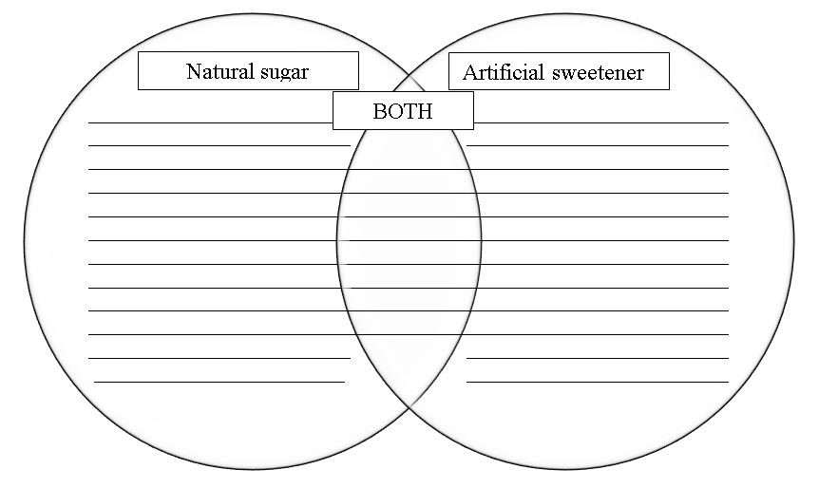

- detrimental health effects.

- synthesized compounds.

- healthier in moderation.

- glucose and fructose.

- low in calories.

- extracted from animal or plant source.

- Beverages

- Baking

- Sweet in taste.

Guide Questions

1. Which sugar contains more nutrients?

Natural sugar

1. What sugar is found in local delicacy “inuyat”?

Molasses

## Activity 7: Honey on Pie

Objective/s

1. Describe the chemical composition on natural sugar - Honey
2. Construct the pie chart to summarize the chemical composition

Direction:

1. Read carefully the text below.

## 2. Show the percentage of the chemical composition of honey using a pie chart

3. **Color and Label** your pie chart.

*Honey contains trace amounts of several vitamins and minerals. As with all nutritive sweeteners, honey is mostly sugaring and is not a significant source of vitamins or minerals. Honey also contains tiny amounts of several compounds thought to function as antioxidants, including chrysin, pinobanksin, vitamin C, catalase, and pinocembrin. The specific composition of any batch of honey depends on the flowers available to the bees that produced the honey.*

*A typical honey analysis goes as follows: Fructose: 38.2%, Glucose: 31.0%, Sucrose:*

*1.5%, Maltose: 7.2%, Water: 17.1%, Higher sugars: 1.5%, Ash: 0.2%, Other/undetermined:*

*3.2%. Honey has a density of about 1.36 kg/L (36% denser than water) (68). The pH of honey is commonly between 3.2 and 4.5. This relatively acidic pH level prevents the growth of many bacteria.*

Construct your pie chart here. **Hint:** each slice of pie is equal to 5%.

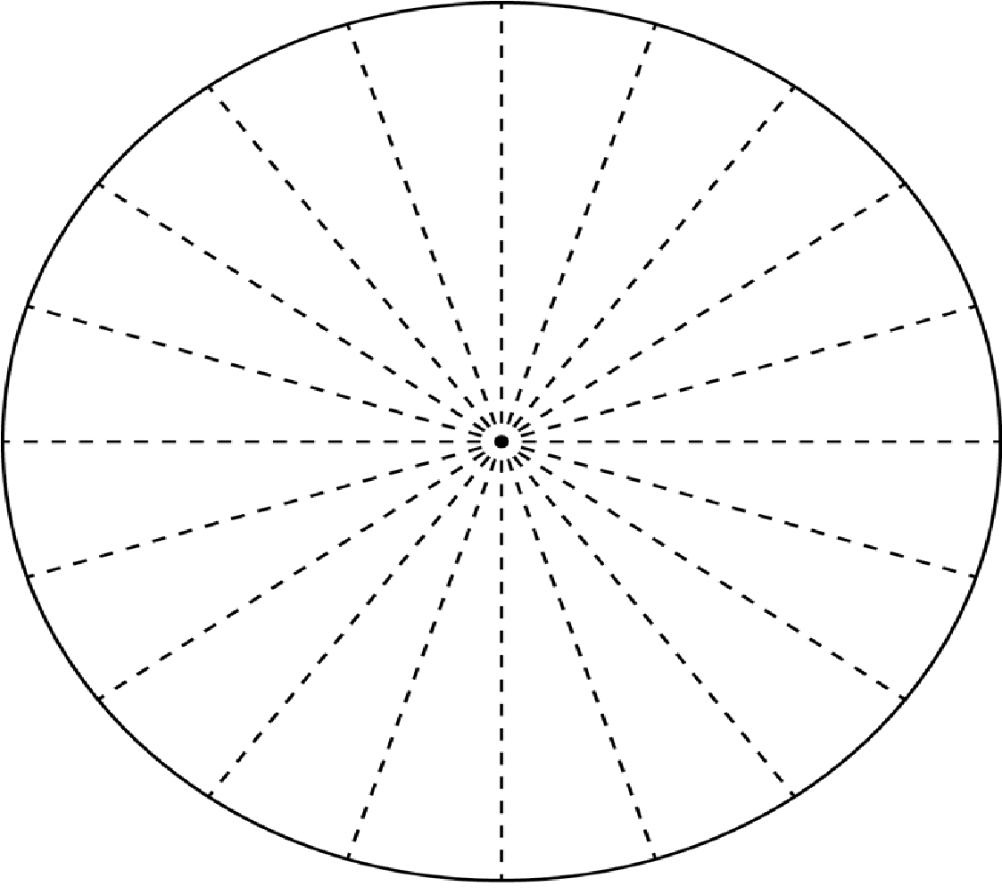

**Title:** _____________________________________________

Guide Questions

1. What are the compounds present on honey?

_____________________________________________________________________________ _____________________________________________________________________ 2. Which compound has the highest percentage?

_____________________________________________________________________________ _____________________________________________________________________ 3. What compound has the lowest percentage?

_____________________________________________________________________________

_____________________________________________________________________

4. Do you think honey is healthier to artificial sweetener? Why or why not?

_____________________________________________________________________________

_____________________________________________________________________

# Reflection

After doing all seven (7) activities, recommend three (3) areas that give awareness on selecting food intake in your every snack or meals.

*1*

*2 3*

________________________________________________________________________

________________________________________________________________________

________________________________________________________________________

________________________________________________________________________

________________________________________________________________________

________________________________________________________________________ ________________________________________________________________________

**References:**

U.S. food & drug administrations. (2018, February 6). Overview of Food Ingredients, Additives & Colors, Retrieved September 1, 2020 from website of U.S. FDA

https://www.fda.gov/food/food-ingredients-packaging/overview-foodingredients-additives-colors#qacolor

Sweeteners discovery, molecular design, and chemoreception. Washington, DC: American Chemical Society, 1991. Print.

**Answer’s Key**

## Activity No. 1

Fact no. 1. baked goods – bread, cookies and pastry have Preservatives, sweeteners, Fat Replacers, Nutrients, Stabilizers and Thickeners, Binders, Texturizers, Leavening Agents

Fact no. 2. baked goods – bread, cookies and pastry have Preservatives, sweeteners, Fat Replacers, Nutrients, Stabilizers and Thickeners, Binders, Texturizers, Leavening Agents

Fact no. 3. frozen dessert – ice cream has Emulsifiers and Fat Replacers

Fact no. 4. Chewing gum – color additives and flavor enhancer

Fact no. 5. Soft drinks – sweeteners and color additive

Guide Questions

1. Food additives is a substance or mixture of substances, other than a basic foodstuff, which is present in a food as a result of any aspect of production, processing, storage, or packaging
2. To Maintain or Improve Safety and Freshness: To Improve or Maintain Nutritional Value:

To Improve Taste, Texture and Appearance:

1. Direct food additives are those that are added to a food for a specific purpose in that food while indirect food additives are those that become part of the food in trace amounts due to its packaging, storage or other handling.

## Activity No. 2

1. Firming Agents 6. Color Additives
2. Flavors and Spices 7. Nutrients
3. Preservatives 8. Emulsifiers
4. pH Control Agents and acidulants 9. Sweeteners
5. Anti-caking agents 10. Emulsifiers

Guide Questions

1. No
2. Potatoes snacks like “pianos” remain crunchy because it has firming agent.
3. ube flavored milk tea has flavor enhancer - ube

## Activity No. 3

1. Color Additives 7. Emulsifiers
2. Flavor Enhancers 8. Fat Replacers
3. Color Additives 9. Stabilizers and Thickeners, Binders,
4. Flavor Enhancers Texturizers
5. Fat Replacers 10. Gases
6. Preservatives

Guide Questions

1. No, pinkish color of nitrate will be overpowered by the natural color of the meat
2. Yes, by adding cheese or tomatoes

5. thickeners, stabilizers, emulsifiers

**Activity No. 4** 6. preservatives

1. colors 7. antioxidants, acidity regulators
2. preservatives 8. antioxidants, acidity regulators
3. surface coating agents, gases, sweeteners 9. acidity regulators, anti-caking agents
4. additional chemicals 10. flavor enhancers

Guide Questions

1. The E **system,** developed by the European Union (formally the European Economic Community), provides a listing of several commonly used additives, pinkish color of nitrate will be overpowered by the natural color of the meat
2. The letter E before the numerical description is the similarity between codes
3. The difference between codes are numerical description.

## Activity No. 5

1. Sugar is a generic term for a category of carbohydrate compounds known as sucrose

(**C12H22O11**).

1. A group of related compounds are corn sugar (called glucose, or dextrose), fruit sugar (fructose), milk sugar (lactose), and malt sugar (maltose).
2. Sucrose is a disaccharide; that is, it is made up of two simple sugars, or monosaccharides— glucose and fructose.
3. It is colourless, water-soluble compounds present in the sap of seed plants and the milk of mammals and making up the simplest group of carbohydrates.
4. The most common sugar is sucrose, a crystalline tabletop and industrial sweetener used in foods and beverages.

Guide Questions

1. These are all organic compounds
2. Carbon, hydrogen and oxygen

## Activity No. 6 SIMILARITIES

* Sweet in taste
* Baking

## - Beverages DIFFERENCES Natural sugar

* extracted from animal or plant source- low in calories
* glucose and fructose.
* Healthier in moderation

## Artificial sweeteners

* synthesized compounds
* detrimental health effects

Guide Questions

1. Natural sugar
2. Molasses

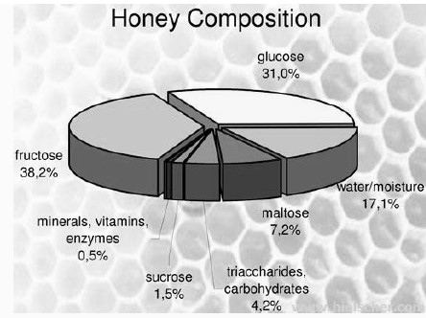

## Activity No. 7

Guide Questions

1. Fructose: 38.2%, Glucose: 31.0%, Sucrose: 1.5%, Maltose: 7.2%, Water:

17.1%, Higher sugars: 1.5%, Ash: 0.2%, Other/undetermined: 3.2%.

1. Fructose
2. Ash
3. yes, because it is natural sugar

Prepared by

RIALITA M. PASCUA

Writer